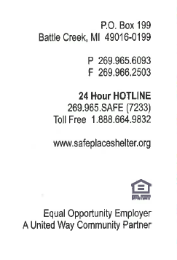
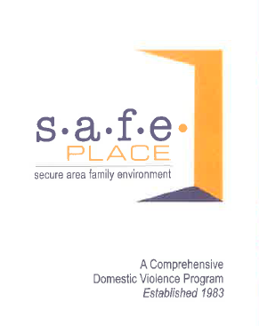
Dear Family,

Your child will soon be involved in an exciting program called SAFER SMARTER TEENS starting JULY 2024 at Bearcat Blast. This effective, research-based program targets the attitudes and behaviors associated with dating abuse and violence. An educator from S.A.F.E. Place and Bronson Sexual Assault Services will be leading these sessions.

Dating abuse can be a significant problem for teens as young as middle Bearcat Blast. SAFER SMARTER TEENS helps youth more clearly define what a healthy dating relationship is and what dating abuse is. It helps them understand the causes and harmful effects of dating abuse, as well as key ways to prevent dating abuse from happening.

We understand that some families don’t want their teens dating until they’re older. SAFER SMARTER TEENS doesn’t push or promote dating, but it will prepare your child for when they may be dating in the future. SAFER SMARTET TEENS also does not discuss any sexually explicit content.

The goal of this program is to help teens be safe as they develop healthy relationships with friends. Our advocates will be onsite as availability allows to answer follow up questions and connect families with resources as needed. This is a free, confidential resource to BEARCAT BLAST students and families.

As the caregiver of your teen, you play the most important role in keeping them safe in dating relationships. If you should have any questions or concerns about the SAFER SMARTER TEENS or dating abuse in general, please do not hesitate to call me at (269) 965-6093 ext. 27.

Sincerely,

Nina Patterson
Prevention Educator, S.A.F.E. Place
npatterson@safeplaceshelter.org

Below is an OPT OUT FORM. Only sign it to stop your child from participating in the program.
------------------------------------------------------------------------------------------------------------
Opt-Out Form
If you do NOT want your child to participate in the Safer Smarter Teens program, please sign below and return this portion of the letter to the Bearcat Blast.
I do NOT want my child _____________________________ (Child’s Name) to participate in the violence prevention program.
x__________________________________________________ (Parent Signature)

